New CATA Fares!
The Cape Ann Transportation Advisory Board voted to approve a new fare structure for CATA and eliminate the fare zones. The new fare structure will go into effect Saturday, June 18, 2022.

Regular Fixed Route CATA Bus
$1.00 one-way full fare
$0.50 one-way reduced fare

Dial-A-Ride and ADA Paratransit CATA Van
$2.00 one-way
Companions ride at $2.00, PCAs ride at no additional cost

Dialysis Service & Ipswich Medical Bus
$2.00 one-way
$20.00 Bus Pass for Six Rides

Stage Fort Park Shuttle & Rockport Shuttle
$1.00 one-way full fare
$0.50 one-way reduced fare

If you have questions or need assistance, please give us a call at 978-283-7916 or email customerservice@canntran.com.

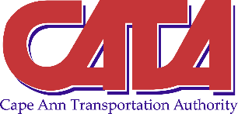

Ipswich/Essex Explorer
$1.00 one-way non-beach full fare
$0.50 one-way non-beach reduced fare
$5.00 full fare to Crane Beach
$3.50 reduced fare to Crane Beach

Mall Bus
$2.50 one-way full fare
$1.25 one-way reduced fare (seniors 60+ and children 5-12)

Student Passes
$100 Semester Pass
$200 Annual Pass
$25 Pass Plus

